Introduction and Statement of the Problem
The primary focus of the project is on building, evaluating, and interpreting regression models for a continuous response (Y) variable using the JMP statistical software.
Specifically, this project seeks to predict median house values in California based on a variety of demographic, housing, and geographic characteristics. Housing prices are influenced by multiple interacting factors such as income levels, housing density, population characteristics, and proximity to major cities and the coastline. Understanding how these factors relate to house values provides an appropriate and meaningful context for regression modeling.

Source of Data
The dataset used in this project is the California Housing dataset, originally derived from the 1990 California Census and later augmented with additional geographic distance variables. The data were obtained from Kaggle
The dataset contains housing-related and demographic information for various districts across California and is well-suited for regression analysis due to its large sample size, predominantly continuous variables, and clear real-world interpretation.
Link: https://www.kaggle.com/datasets/fedesoriano/california-housing-prices-data-extra-features

Description of the Dataset
The dataset consists of:
- Number of observations (rows): 20,640
- Number of variables (columns): 14
The dataset is cross-sectional in nature and is not a time-series dataset, as it does not contain a date or time variable. Therefore, all observations represent housing characteristics measured at a single point in time. No missing values were present in the dataset.

Definition of Target (Y) Variable
The response variable selected for this project is:
Median_House_Value (Y)
- Type: Continuous
- Description: The median house value (in U.S. dollars) for houses in a given California district.
This variable takes on a wide range of values and represents a natural continuous outcome, making it suitable for regression modeling. The goal of the analysis is to predict this variable using relevant explanatory variables.
Definition of Predictor (X) Variables
Based on domain knowledge and exploratory considerations, the following predictor variables were selected. These variables represent demographic, housing stock, population, and geographic characteristics that may influence housing prices.

Variable Name | Type | Description
Median_Income | Continuous | Median household income in the district
Median_Age | Continuous | Median age of houses in the district
Tot_Rooms | Continuous | Total number of rooms in the district
Tot_Bedrooms | Continuous | Total number of bedrooms in the district
Population | Continuous | Total population in the district
Households | Continuous | Number of households in the district
Latitude | Continuous | Latitude of the district
Longitude | Continuous | Longitude of the district
Distance_to_coast | Continuous | Distance (km) to the nearest coastline
Distance_to_LA | Continuous | Distance (km) to Los Angeles
Distance_to_SD | Continuous | Distance (km) to San Diego
Distance_to_SJ | Continuous | Distance (km) to San Jose
Distance_to_SF | Continuous | Distance (km) to San Francisco

A total of 13 predictor variables were considered.
Justification of Variable Selection
The selected predictor variables were chosen because they provide independent and meaningful information about housing prices. None of the predictor variables directly define the response variable, avoiding the common modeling pitfall where predictors trivially determine the outcome.
The predictors capture multiple dimensions affecting house values:
- Economic factors (Median_Income)
- Housing stock characteristics (Median_Age, Tot_Rooms, Tot_Bedrooms)
- Population density and household structure (Population, Households)
- Geographic location (Latitude, Longitude)
- Proximity to major cities and coastline (distance variables)

Modeling Approach Overview
Because the response variable is continuous, multiple linear regression is the primary modeling technique used.
The modeling process includes:
- Exploratory data analysis and visualization
- Estimation of an initial full regression model
- Model selection using formal selection methods
- Diagnostic checking through residual analysis
- Evaluation of model performance using appropriate metrics
- Selection and interpretation of a final model

Check distributions:
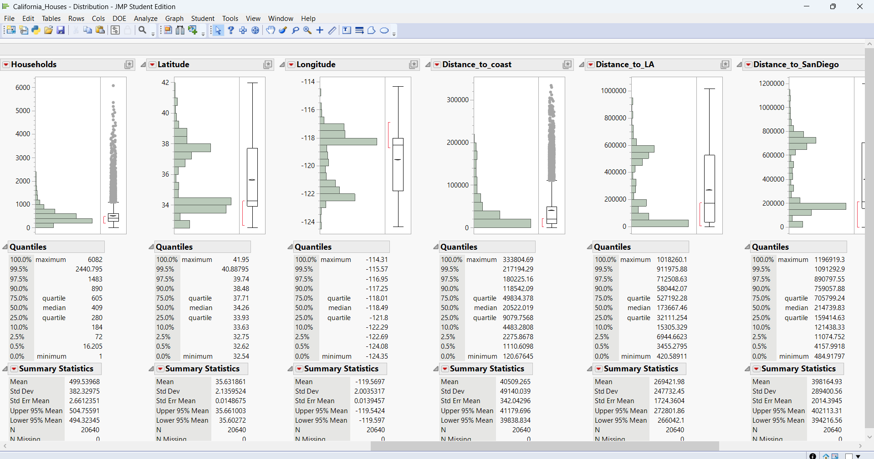
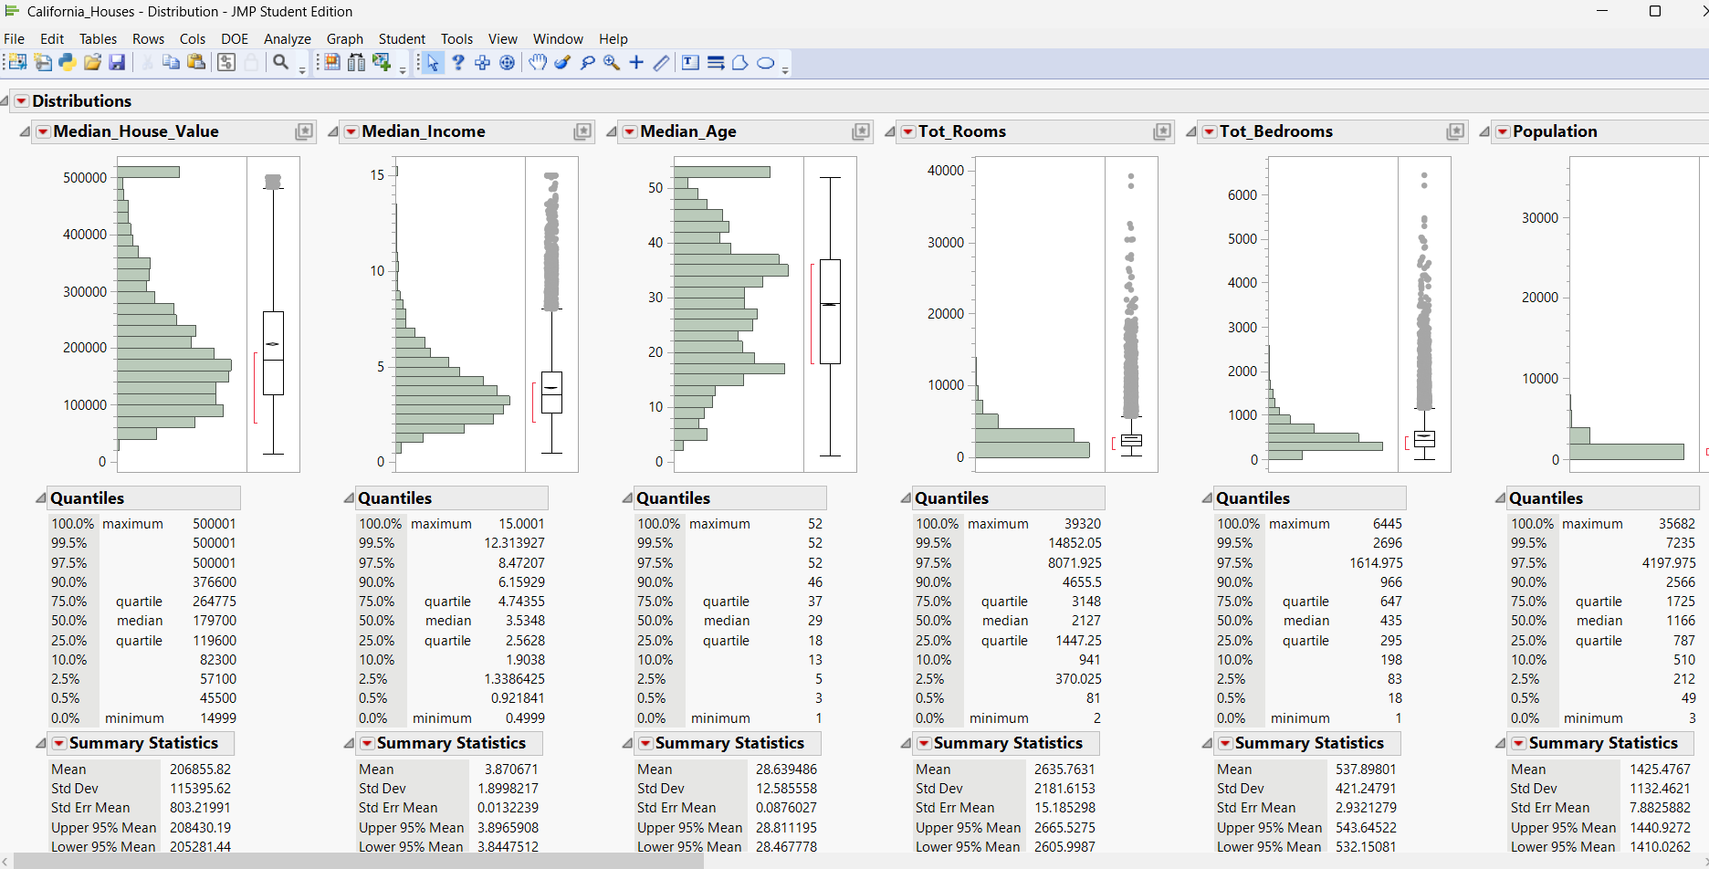
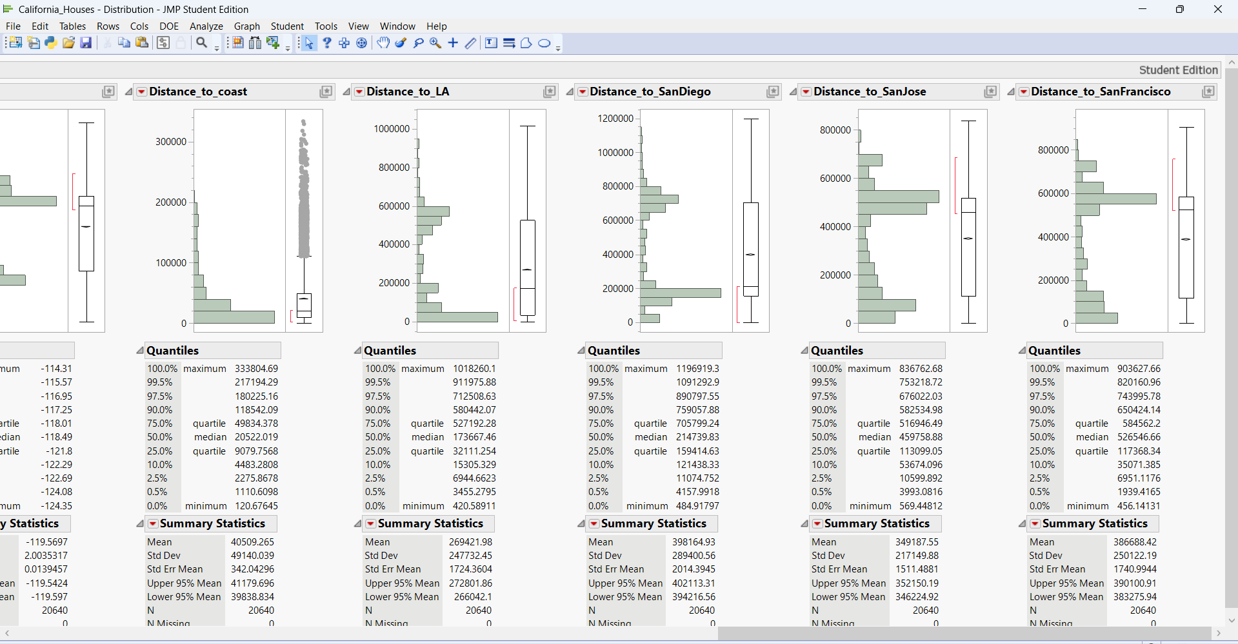
Exploratory Data Analysis (EDA)
An exploratory data analysis was conducted using the Distribution platform in JMP to understand the behavior of the response and predictor variables before model building.
Response Variable: Median_House_Value
- Continuous response variable representing median house prices.
- Distribution is right-skewed with a long upper tail.
- Large spread indicates substantial variability across districts.
- Presence of high-value observations suggests potential outliers.
- Variable retained in original scale for initial modeling; transformations may be considered after diagnostics.
Median_Income
- Moderately right-skewed distribution.
- Majority of districts fall in lower to mid income ranges.
- Expected to be a strong predictor of house values.
Median_Age
- Relatively symmetric distribution.
- Wide range from newer to older housing districts.
- No immediate concerns regarding extreme skewness.
Tot_Rooms and Tot_Bedrooms
- Strong right skewness observed.
- Several large values in the upper tail.
- Potential multicollinearity expected among room-related variables.
Population
- Highly right-skewed.
- Most districts have smaller populations; few very large districts.
Households
- Right-skewed distribution similar to Population.
- Indicates a strong relationship between population and household counts.
Latitude and Longitude
- Distributions reflect California’s geographic structure.
- Clustering around populated regions.
- Included to capture spatial effects on housing prices.
Distance-Based Variables
(Distance_to_coast, Distance_to_LA, Distance_to_SanDiego, Distance_to_SanJose, Distance_to_SanFrancisco)
- All distance variables are right-skewed.
- Most districts are relatively close to at least one major city or the coast.
- Useful for capturing geographic proximity effects.

Check correlations:
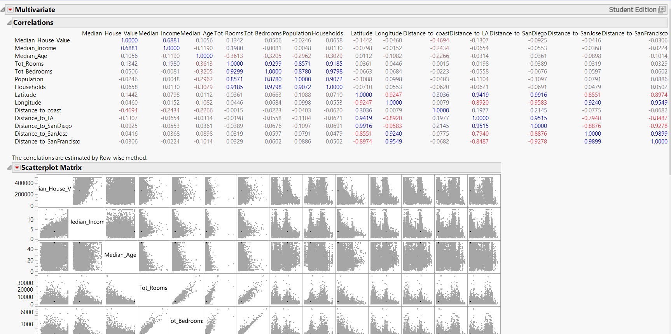
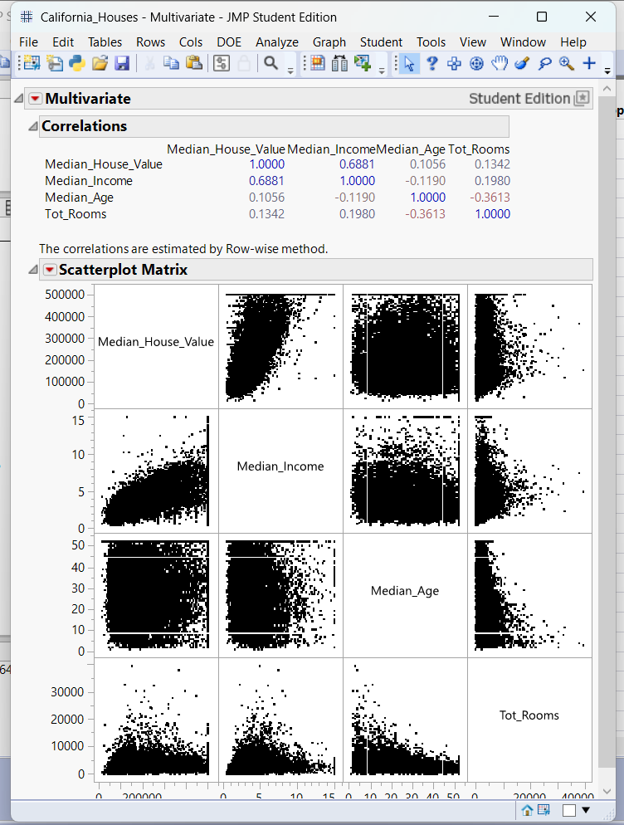

Pair | Correlation | Interpretation
Median_House_Value ↔ Median_Income | 0.6881 | Strong positive relationship (very good predictor)
Median_House_Value ↔ Median_Age | 0.1056 | Very weak relationship
Median_House_Value ↔ Tot_Rooms | 0.1342 | Weak relationship
Median_Age ↔ Tot_Rooms | –0.3613 | Moderate negative correlation
Summary of Correlation Findings
- Median_Income shows the strongest linear relationship with the response variable.
- Distance_to_coast also demonstrates a meaningful negative correlation with house values.
- Several predictors have weak individual correlations but may still contribute jointly in a multivariate regression setting.
- Strong correlations among some predictors (e.g., room counts and population-related variables) suggest potential multicollinearity, reinforcing the need for formal model selection.

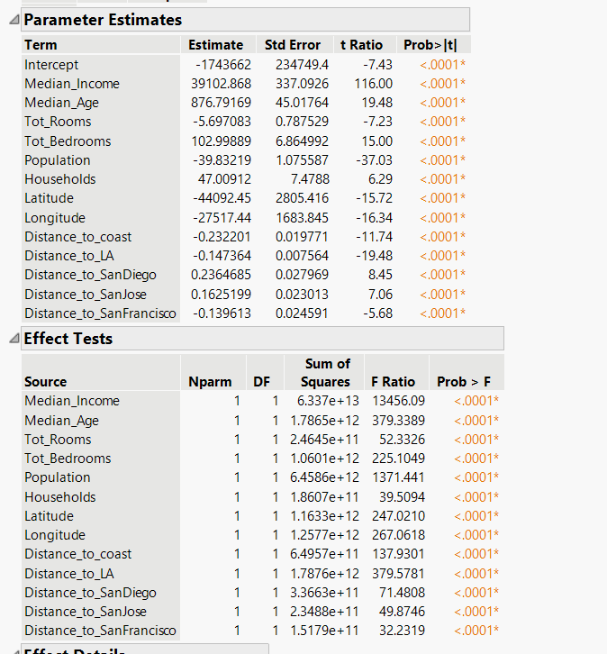

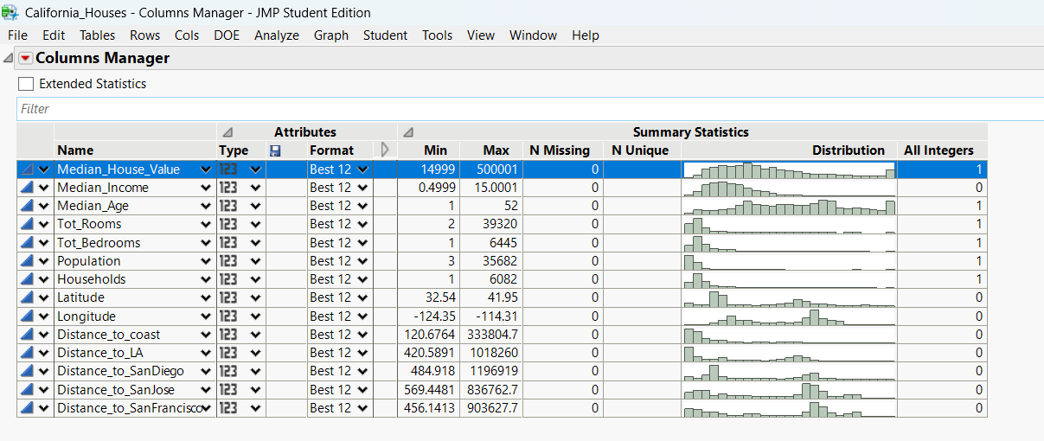

Splitting the data :
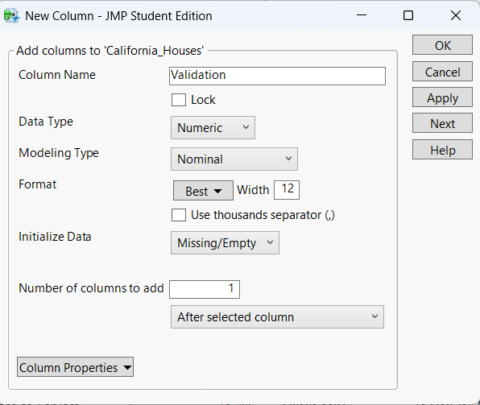

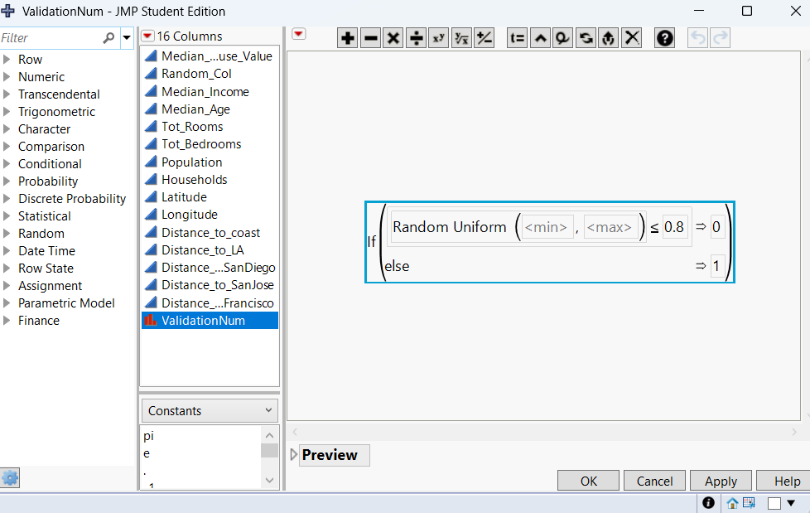
Data Partitioning: Training and Validation
To evaluate model performance and support formal model selection, the dataset was partitioned into training and validation subsets using JMP.
- A new column named Validation was created in the dataset.
- The column was defined as:
  - Data Type: Numeric
  - Modeling Type: Nominal
- This column serves as an indicator variable to identify training versus validation observations.
Random Assignment Procedure
- A calculated column (ValidationNum) was generated using a random uniform distribution.
- The following logic was applied:
  - Observations with a random value ≤ 0.80 were assigned to the training set.
  - Observations with a random value > 0.80 were assigned to the validation set.
- This resulted in an approximate 80% training / 20% validation data split.

Regression Model:
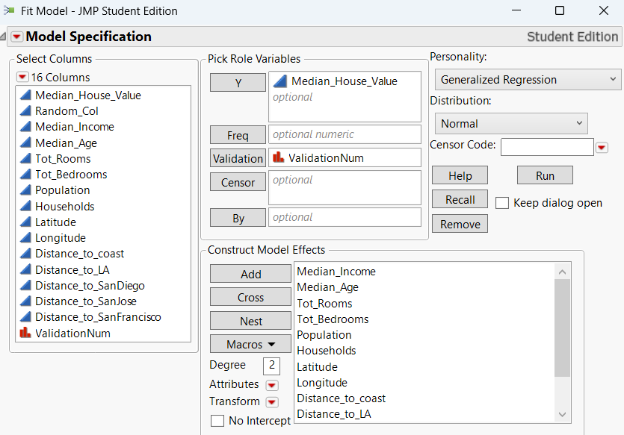

- The Validation column is assigned the Validation role in JMP’s Fit Model platform.
- Regression models are evaluated using both training and validation performance metrics.

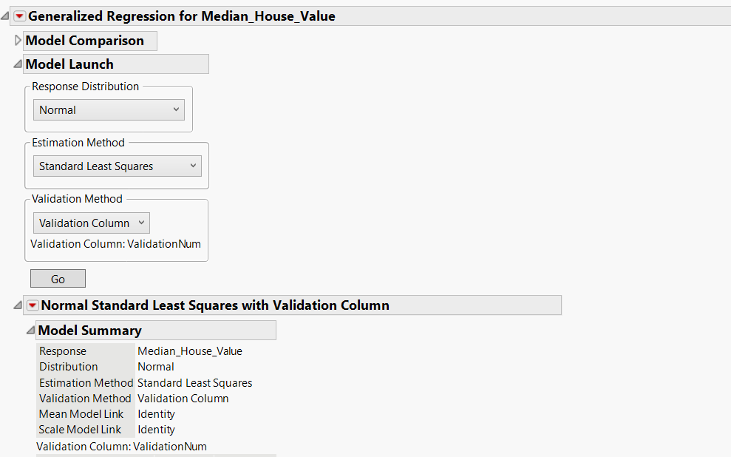

Model Setup
- Response Variable: Median_House_Value
- Response Distribution: Normal
- Link Function: Identity
- Model Type: Multiple Linear Regression

Estimation Method
- Estimation Method Used: Standard Least Squares
- Selected to establish a baseline linear regression model.
- Provides interpretable coefficient estimates and standard diagnostic outputs.

Validation Strategy
- Validation Method: Validation Column
- Validation Column Used: ValidationNum
- The previously created training/validation split was incorporated directly into model estimation.
- Enables comparison of model performance on training versus validation data.

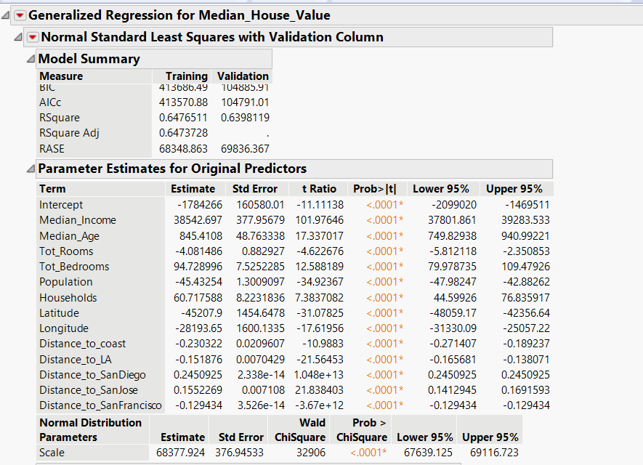

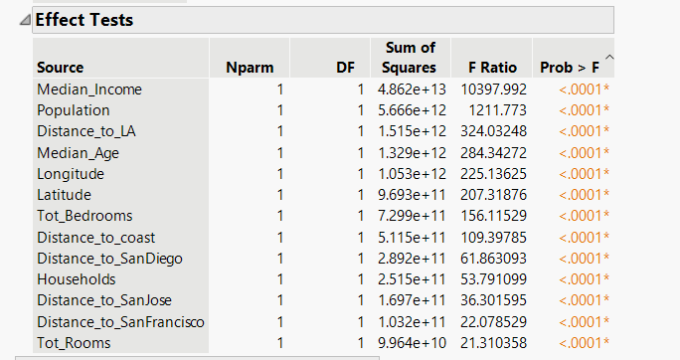

Regression Model Results
A multiple linear regression model was estimated using Standard Least Squares with a validation column to assess both training and validation performance.

Model Performance (Training vs Validation)
- R² (Training): 0.648
- R² (Validation): 0.640
- The model explains approximately 64% of the variability in median house values.
- Similar training and validation R² values indicate good generalization and limited overfitting.
- RASE (Training): 68,349
- RASE (Validation): 69,836
- Comparable error values further confirm model stability across datasets.

Interpretation of Key Parameter Estimates
(All predictors are statistically significant with p < 0.0001.)
- Median_Income
  - Strong positive effect on house value.
  - Higher income districts are associated with substantially higher house prices.
  - Largest t-ratio, indicating strongest influence.
- Median_Age
  - Positive relationship with house value.
  - Older housing districts tend to have higher median values.
- Tot_Rooms
  - Negative coefficient.
  - Suggests larger total room counts are associated with lower median values when controlling for other factors.
- Tot_Bedrooms
  - Positive effect on house value.
  - Indicates housing composition matters beyond total room count.
- Population
  - Negative relationship with house value.
  - Higher population density is associated with lower median house prices.
- Households
  - Positive effect, indicating areas with more households tend to have higher values when holding population constant.

Geographic and Distance Effects
- Latitude and Longitude
  - Both are statistically significant.
  - Capture important spatial patterns in California housing prices.
- Distance_to_coast
  - Negative coefficient.
  - Houses closer to the coast tend to have higher values.
- Distance_to_LA
  - Negative relationship with house value.
  - Proximity to Los Angeles increases housing prices.
- Distance_to_SanDiego, SanJose, and SanFrancisco
  - Statistically significant effects.
  - Reflect the influence of proximity to major metropolitan areas.

Effect Tests (Overall Importance)
- All predictors have significant F-tests (p < 0.0001).
- Median_Income shows the largest F-ratio, confirming it as the most influential predictor.
- Population, geographic location, and distance variables also contribute meaningfully to the model.

Removing outliers
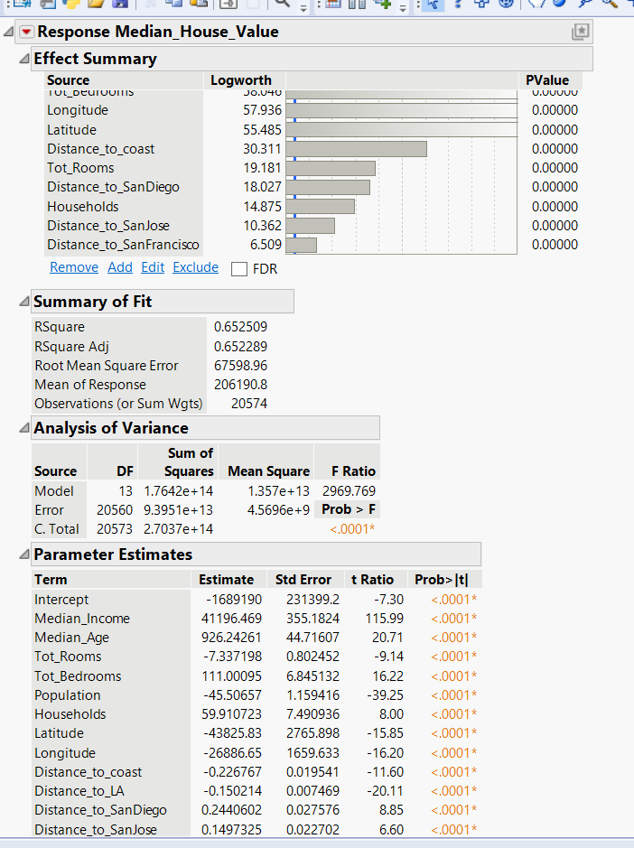

Outlier Handling
- Diagnostic evaluation identified a small number of extreme observations.
- These observations exhibited unusually large residuals and high influence.
- Such points can disproportionately affect coefficient estimates and error metrics.
- The identified outliers were removed, and the model was refit using the remaining data.
Updated Model Performance (After Removing Outliers)
- Number of observations: 20,574
- R²: 0.653
- Adjusted R²: 0.652
- Root Mean Square Error (RMSE): 67,599
- The model explains approximately 65% of the variability in median house values.
- Slight improvement in model fit and error compared to the initial model.
Effect Summary Interpretation
- All retained predictors remain statistically significant (p < 0.0001).
- Median_Income continues to be the most influential predictor.
- Geographic variables (Latitude, Longitude, Distance_to_coast) remain highly important.
- Housing stock and population-related variables continue to contribute meaningfully.
- The ranking of variable importance remains consistent, indicating model robustness.
Updated Parameter Estimates
- Coefficient signs and magnitudes remain stable after outlier removal.
- Direction of relationships aligns with economic and geographic intuition.
- Removal of outliers improved interpretability without changing core conclusions.
Conclusion of Outlier Analysis
- Outlier removal resulted in a more stable and reliable model.
- Predictive performance improved slightly while preserving explanatory structure.
- The refined model is selected as the final regression model for interpretation and reporting.

Conclusion and Recommendations
- The objective of this project was to develop a predictive regression model for Median House Value in California using demographic, housing, and geographic variables. Using JMP, a complete modeling workflow was conducted, including exploratory analysis, correlation assessment, model estimation, validation-based model selection, and diagnostic checks.
- The final regression model explains approximately 65% of the variability in median house values and demonstrates stable performance across training and validation datasets, indicating good generalization. Median income emerged as the most influential predictor, followed by geographic location and proximity to major cities and the coastline. Housing composition and population-related variables also contributed meaningfully to the model.
- Diagnostic analysis, including outlier assessment, showed that the model results were robust and that the overall conclusions were not sensitive to a small number of extreme observations. While the model does not perfectly predict house values, it provides meaningful insight into the key factors influencing housing prices in California.
- Future work could explore nonlinear relationships, interaction effects, or alternative modeling approaches such as regression trees to further improve predictive performance. Overall, this project successfully demonstrates the application of regression modeling techniques.

